# Smart Waste Bin – Sensor and Component Wiring

This document outlines the wiring and GPIO connections used for all sensors and components in the Smart Waste Bin Monitoring System. The setup was implemented on a Raspberry Pi using GPIO pins and a breadboard.

## Ultrasonic Distance Sensor (HC-SR04)

|  |  |  |
| --- | --- | --- |
| Component Pin | Raspberry Pi GPIO / Pin | Description |
| VCC | Pin 2 (5V) | Power supply via positive rail |
| GND | Pin 9 (GND) | Connected via negative rail |
| TRIG | Pin 16 (GPIO 23) | Connected directly to breadboard and GPIO |
| ECHO | Pin 18 (GPIO 24) | Connected through voltage divider (1kΩ + 2kΩ) to GPIO |

## Weight Sensor (HX711 via I2C)

|  |  |  |
| --- | --- | --- |
| Component Pin | Raspberry Pi GPIO / Pin | Description |
| VCC | Pin 1 (3.3V) | Power input |
| GND | Pin 6 (GND) | Ground |
| SCL | Pin 5 (GPIO 3) | I2C Clock |
| SDA | Pin 3 (GPIO 2) | I2C Data |

## PIR Motion Sensor

|  |  |  |
| --- | --- | --- |
| Component Pin | Raspberry Pi GPIO / Pin | Description |
| GND | Pin 14 (GND) | Negative rail |
| VCC | Pin 4 (5V) | Positive rail |
| OUT | Pin 11 (GPIO 17) | Signal pin connected via breadboard |

## LED Indicator

|  |  |  |
| --- | --- | --- |
| Component Pin | Raspberry Pi GPIO / Pin | Description |
| Anode (+) | Pin 22 (GPIO 25) | Connected via resistor to GPIO |
| Cathode (–) | Pin 6 (GND) | Connected via negative rail |

**Setting Up the Hardware**

To assemble the Smart Waste Bin Monitoring System, begin by connecting each sensor to the Raspberry Pi GPIO pins according to the wiring tables below. All components are wired using standard jumper cables and a breadboard for prototyping.

**1. Ultrasonic Sensor (HC-SR04)**

* Connect VCC to the 5V rail (+) via GPIO Pin 2 and GND to the ground rail (-) via Pin 9.
* The **TRIG** pin goes to GPIO 23 (Pin 16), directly connected via the breadboard.
* The **ECHO** pin connects to GPIO 24 (Pin 18) **via a voltage divider** using 1kΩ and 2kΩ resistors to drop the 5V output to a Pi-safe 3.3V.

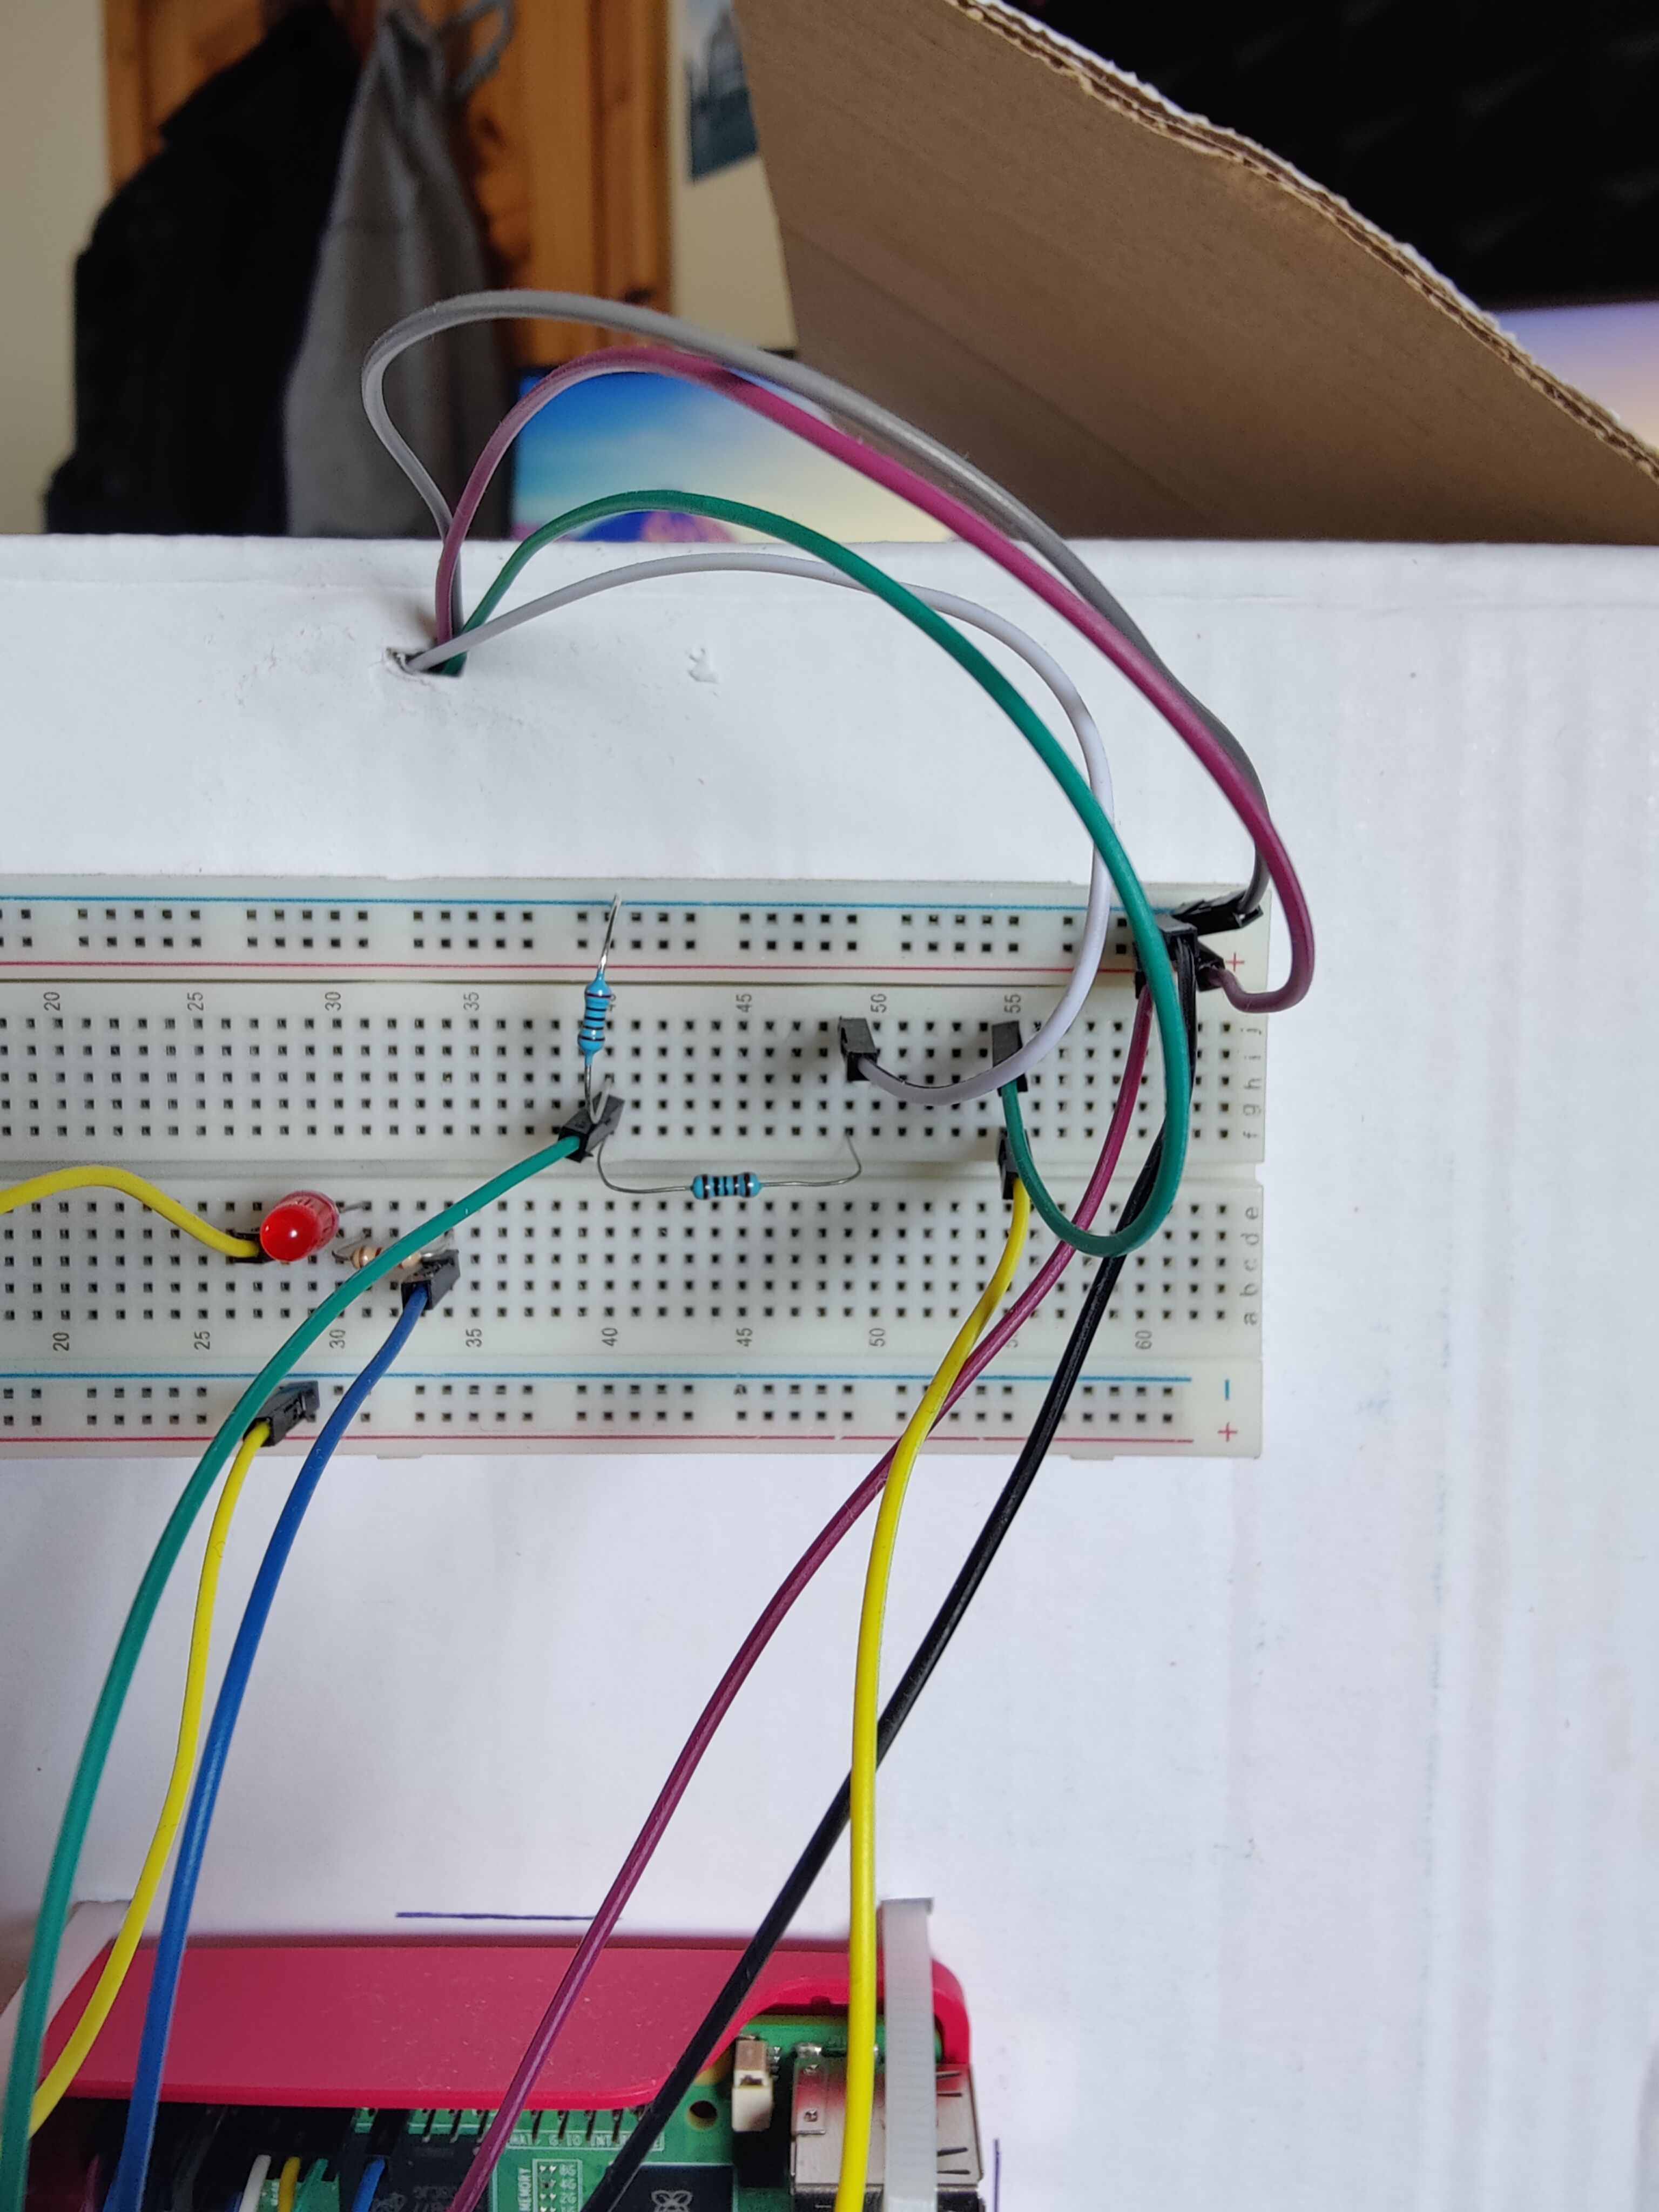

Figure . Wiring for Ultrasonic Sensor

**2. Weight Sensor (HX711 Module)**

* Connect the module’s VCC to GPIO Pin 1 (3.3V) and GND to Pin 6.
* SCL and SDA are connected to GPIO 3 (Pin 5) and GPIO 2 (Pin 3) respectively, which are the default I2C pins on the Pi.
* This sensor is mounted directly to the bin and connects via four jumper wires.

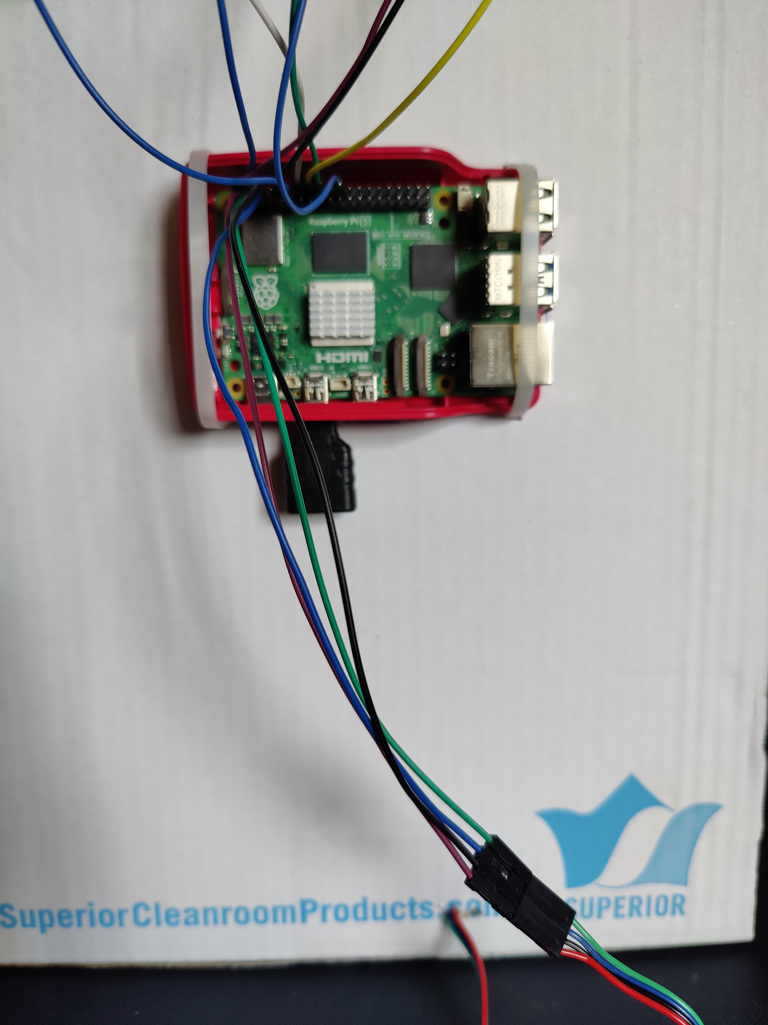

Figure . Wiring for Weight Sensor

**3. PIR Motion Sensor**

* Connect GND to the Pi’s ground rail (-) via Pin 14.
* Connect VCC to the 5V rail (+) via Pin 4.
* The signal **OUT** pin connects to GPIO 17 (Pin 11) through the breadboard.

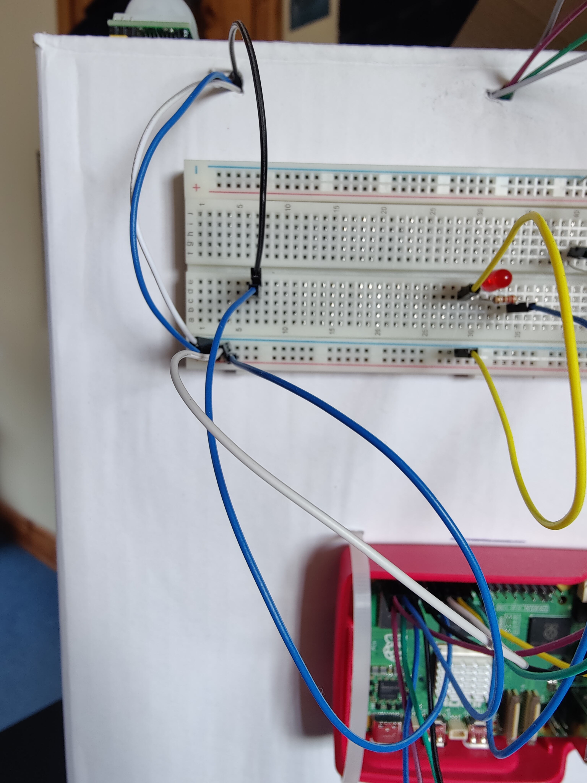

Figure . Wiring for PIR Sensor

**4. LED Indicator**

* The LED is placed on the breadboard with the **anode (longer leg)** connected to GPIO 25 (Pin 22) **via a resistor (220 ohm)**, and the **cathode** wired to the ground rail.
* This LED activates when the fill level reaches 80%.

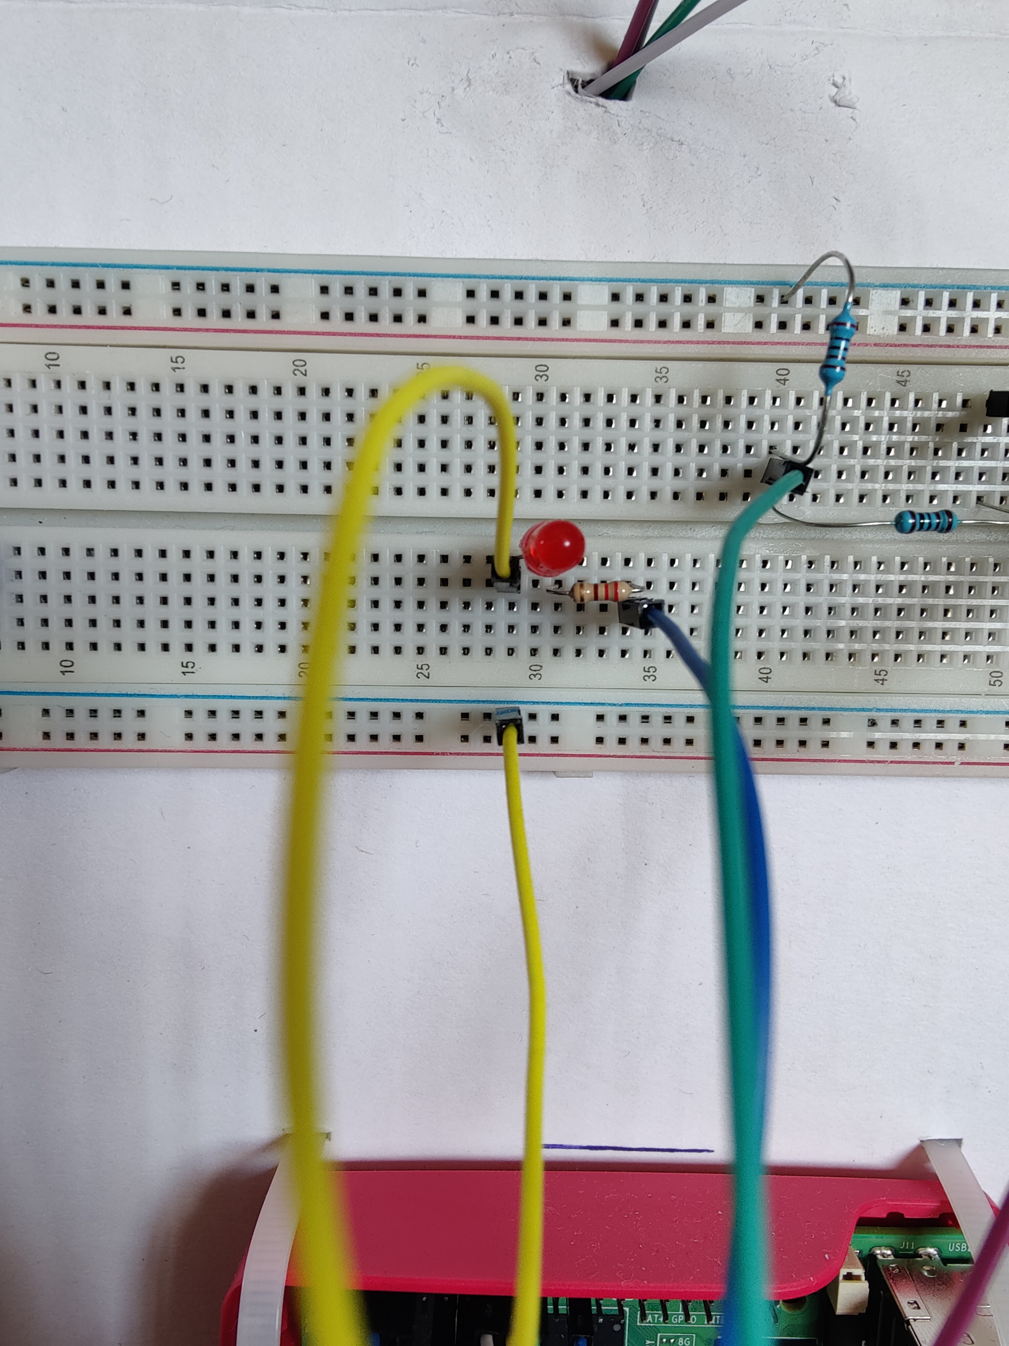

Figure . Wiring for LED